PATRICK M. YOUNG, director
mayor’s office of gun violence prevention | city of new orleans

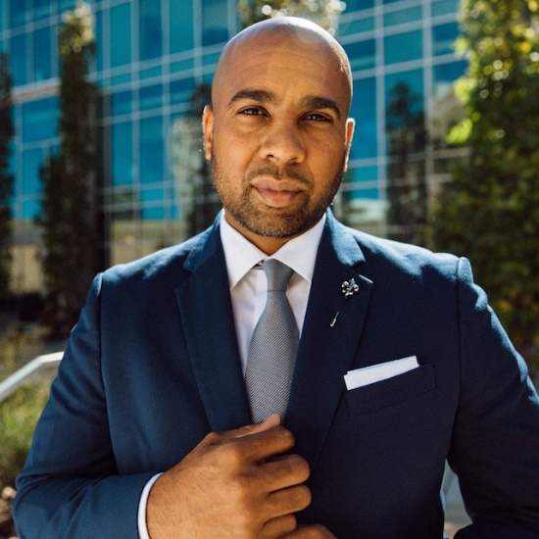
PATRICK M. YOUNG serves as the director of the Mayor’s Office of Gun Violence Prevention (OGVP) for the City of New Orleans. During Mayor LaToya Cantrell’s first year in office, she released the Generational Gun Violence Reduction Plan aimed at decreasing the city’s incidences of gun-related injuries and deaths over the next 50 years. Under Patrick’s leadership since April 2021, OGVP has addressed gun violence prevention from a public health approach where the city’s residents are provided and empowered with trauma-intervention services and resources from crisis interventionists, partnering agencies and institutions, community stakeholders and evidence-based policymaking.
Prior to working in Mayor Cantrell’s administration, Patrick served as training manager of Talent and Workforce Development at New Orleans Business Alliance (NOLABA). In partnership with four local opportunity centers, Patrick oversaw trainers who taught a New Orleans-based model of the STRIVE® Work Readiness Training Program. In less than three years, Patrick helped more than 890 formerly incarcerated persons gain full-time employment and potential career pathways ─ directly contributing to New Orleans’ robust labor force based on the 4-week curriculum that taught them professional development and soft skills training.
Patrick is the Founder and Executive Director of SHARP MEN, a non-profit that provides professional attire to men striving to overcome workforce barriers to employment. Based on his passion and follow-through as an inspiring leader and role model, Patrick was recognized as a 2021 W.K. Kellogg Foundation Community Leadership Fellow for his proven leadership and dedication to making the City of New Orleans one of the best cities in the world. And more recently, Patrick was requested to be a part of Orleans Parish District Attorney Jason Williams’ transition team.
During the shelter-in-place phase of the COVID-19 pandemic, Patrick became the first-time author of A Way Up: Economic Development Post Incarceration, a guide that offers strategies for wealth-building after a conviction. He is a certified community organizer from Midwest Organizing Academy; a certified Advanced Core Trainer from STRIVE® International; a graduate of the New Orleans Business Alliance Economic Development Ambassadors Program; a Nancy M. Marsiglia Institute of Justice Fellow; a recipient of the 100 Black Men of New Orleans Innovator of the Year Award; and owner and operator of the training and consulting company, Raise Your Bar, LLC. But his most proud accomplishment and most important responsibility is being father to his daughter, Paris, and to his son, Paxton.

“We have to create spaces of healing not just recycle traumas.” patrick m. young

